Presentation Proposal Worksheet

Questions to Consider Before You Begin:

What key takeaways will you share that will help attendees make an impact on campus?

How will you actively involve participants?

What will set your presentation apart from others at the conference?

How does the planned format of your session allow for interaction and conversation among audience members?

How does your topic influence higher ed human resource work?

If you were to rank your topic on a scale of 1-5 (1 being very low and 5 being very high) in terms of its relevance or timeliness for higher ed HR pros, what ranking would you assign?

Does the presentation promote or sell specific products, services or companies? If so, your session will NOT be accepted.

Session Title
Summarize your session. Can you do it in less than 45 characters? If so, you’re on your way to a great title. Please limit the title to 75 characters. Do not use abbreviations, acronyms or trademarks. The title may be edited by CUPA-HR to clearly reflect the content of the session.

Session Format
You are strongly urged to consider formats other than a lecture to encourage an exchange of information between yourself and attendees and among attendees. Please check your proposed format.
- Case Study — A presenter interacts with an audience to examine work situations and solutions
- Lecture — A presenter shares information — often utilizing just a PowerPoint presentation — with little to no audience interaction
- Panel — A small group of presenters shares information with the audience, which might be asked to offer their views
- Role-Play — Individuals act out situations to illustrate points
- Roundtable — A facilitator encourages the sharing of information within and among groups
- Other (please specify)
___________________________________
Packing information and insight on a topic into a fifteen-minute segment, microsessions provide additional insight from a concurrent session or expound upon a specific tool, element, process, etc. These educational sessions are less formal and shorter than concurrent sessions, typically offering 7-10 minutes of content and 5-8 minutes for Q&A. Microsessions are selected from invited concurrent sessions.

I would like this session to also be considered for a microsession.

CUPA-HR Learning Framework
The CUPA-HR learning framework is a foundation for understanding the many essential skills necessary to succeed in higher education, human resources and higher education human resources. The framework competencies:

- support higher ed HR professionals and their contributions to the institution in general and to their teams specifically
- cover an extensive spectrum, ranging from navigating change to being institutional strategic partners
- overlap in a way that shows that they build upon/rely on one or several other competencies
- assist with how to advance in a higher ed HR career

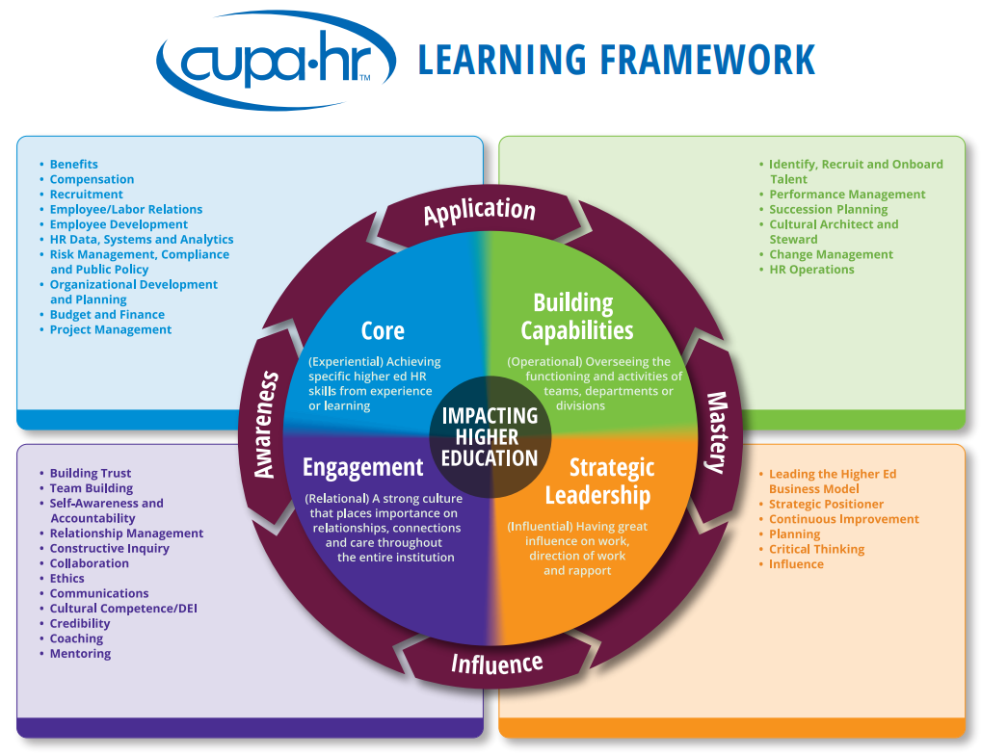
After thinking about the information that you will share in your presentation, how well will it complement the areas and competencies illustrated in the framework? To help us understand the fit, select the following:
- Area — Your session should fall into one of the four outlined areas. Each area represents the essential qualities of higher ed HR work. Please select the area that best fits your session.
- Framework Competencies — Please select the framework competencies to which your session applies.
- Conference Track — Choose the conference track(s) that applies to your proposal.
Learning Framework Area
- Core
- Building Capabilities
- Engagement
- Strategic Leadership

Learning Framework Areas

Core
- Benefits
- Compensation
- Recruitment
- Employee/Labor Relations
- Employee Development
- HR Data, Systems and Analytics
- Risk Management, Compliance and Public Policy
- Organizational Development and Planning
- Budget and Finance
- Project Management
Building Capabilities
- Identify, Recruit and Onboard Talent
- Performance Management
- Succession Planning
- Cultural Architect and Steward
- Change Management
- HR Operations
Engagement
- Building Trust
- Team Building
- Self-Awareness and Accountability
- Relationship Management
- Constructive Inquiry
- Collaboration
- Ethics
- Communications
- Cultural Competence/DEI
- Credibility
- Coaching
- Mentoring
Strategic Leadership
- Leading the Higher Ed Business Model
- Strategic Model
- Continuous Improvement
- Planning
- Critical Thinking
- Influence

Conference Track
Select the conference track to which your session applies.
  - Academic HR
  - Diversity, Equity and Inclusion/Cultural Competencies
  - HR Data, Systems and Analytics
  - HR Operations
  - Organizational Development and Professional Development
  - Risk Management, Compliance and Public Policy
  - Strategy
  - Talent Management
  - Total Rewards
  - Other
If you have questions about how your session topic idea fits into the framework, e-mail learn@cupahr.org for help.

Promotional Description (For Publication in Conference Material)
Tell your audience about your presentation. Why should they come to your session? What will they learn? How will it make them a better HR professional? If your proposal is selected, the information you provide will be the basis for conference publicity. Avoid using jargon as clarity is paramount in describing what your audience will learn or be able to do at or after your session. The description will be edited for use in conference materials. You may only enter a maximum of 500 characters. See below example:

Sample Session Description
Impact Mapping: A Tool to Help Elevate HR’s Strategic Approach
As HR leaders, we need to think strategically to help the institution accomplish its goals. However, many HR professionals have more experience navigating complex problems in technical ways. An impact map is a tool that can help you think through the resources needed to take critical action toward key results. Using a case study approach, this session will introduce you to an impact mapping tool and help you create your own map for an initiative on campus.

Your promotional description:

Outline
A one-page outline covering the major discussion points of the proposal. (This will only be used during the selection.)

Target Institutions
Because all institution types are unique, it can be difficult to develop a presentation to benefit everyone. Think about how your presentation will benefit those from more than one institution type.

From which types of institutions will HR professionals benefit most from this session?

- Large Public Institutions
- Small Public Institutions
- Private Institutions
(Not-for-Profit)

- Private Institutions (For-Profit)
- Two-Year Institutions

HR Challenges
What human resources challenge will this presentation address?

Learning Objectives
Each session must have at least three learning objectives.

Sample Learning Objectives
Meeting Disability With Creativity and Understanding
At the end of this session, attendees will be able to:
- Develop greater comfort with addressing disability issues.
- Learn about a creative approach for developing greater understanding of and for people with disabilities on your campus.
- Receive support and ideas from colleagues on how to expand the conversation and sense of inclusion for people with disabilities.

The learning objectives for your session are:

Contact Person
If you are not a presenter, but you are the contact person, please enter your name and e-mail address.
First:
Last:
Your E-mail Address:

You will have the opportunity to also add information for additional speakers:

First:
Last:
Title:
Address 1:
Address 2:
City:
State:
Zip:
Telephone:
Fax:
E-mail:
CUPA-HR member institution?
Yes
No
Corporate partner of CUPA-HR?
Yes
No
Have you presented at a previous CUPA-HR event?
Yes
No
If yes, please indicate the year, the name of the event and your audience evaluation:
Speaker Information (used for HRCI purposes only)
Please provide the speaker's educational background and certifications.
Example: B.A., Philosophy, University of South Carolina; M.B.A., Boston College; Ph.D., Psychology, University of Wisconsin; GPHR; CCP

