Crafting Your Conference Session Proposal – A Step-by-Step Guide

1. Define Your Basic Idea(s)
Use this section to organize your session proposal ideas before you begin drafting your submission in the following sections.

What topic(s) will you be presenting on?

What challenges will your session help others to overcome?

What do you hope your audience will take away from your presentation?

All CUPA-HR learning is connected to the Learning Framework. How does your proposed topic relate to the Learning Framework?

What format do you anticipate your presentation will take?
⇨ Case Study ⇨ Lecture ⇨ Roundtable ⇨ Panel ⇨ Role-Play ⇨ Other _______________

Could you co-present with a campus colleague or a professional from another institution to give your session more depth? This is by no means a requirement but could increase perceived applicability to and interest of attendees of varying institution sizes and types.

Who will be your speaker(s)?

Does the presentation promote or sell specific products, services or companies? If so, your session will NOT be accepted.

2. Refine the Specifics
Use this section to draft your session proposal. The fields align with the online proposal form, so once you have drafted and reviewed your proposal details you can simply transfer them into the form to expedite submission.

Presentation Title:
Your title should clearly and accurately convey the topic of your presentation in 75 characters or fewer. Try to avoid abbreviations, unfamiliar acronyms, trademarks, jargon and any other potentially confusing terminology. Please note that titles may be edited by CUPA-HR where necessary.

Example title:
Introduction to the Interactive Process Under the ADA

Tip: Your title will set your audience’s expectations, so remember to be catchy but clear!

Presentation Description:
Your description should tell your audience what your presentation is in 300 characters or fewer. If your proposal is selected, this information will be used in the session description and other conference materials. Try to avoid abbreviations, unfamiliar acronyms, trademarks, jargon and any other potentially confusing terminology. Please note that descriptions may be edited by CUPA-HR where necessary.

Example description:
This presentation will serve as a basic introduction and overview of the Interactive Process as defined under the Americans with Disabilities Act (ADA). In our presentation, we’ll touch on what a request for accommodation might look like and talk about some critical HR “dos” and “don’ts” of the process.

Tip: You’ll be limited to 300 characters on the official form, so try to focus on substance over style.

Learning Objectives:
All proposals are required to submit three learning objectives in order to be considered (each containing 100 characters or fewer). What skills, strategies, information, tools or other knowledge will your audience gain from your presentation?

Example learning objectives:
At the end of this presentation, attendees will:
- Develop a greater awareness of the ADA
- Understand how to approach the interactive process
- Identify requests for accommodation

At the end of this presentation, attendees will:
1.

2.

3.

Presentation Type:
- Case Study — A presenter interacts with an audience to examine work situations and solutions
- Lecture — A presenter shares information, typically with little or no audience interaction
- Roundtable — A facilitator encourages the sharing of information within and among groups
- Panel — A small group of presenters shares information with the audience
- Role-Play — Individuals act out situations to illustrate points
- Other — (If Other please describe)

3. Determine Where Your Topic(s) Fit
Use this section to specify how your session proposal aligns with the CUPA-HR Learning Framework and where it fits within the conference session tracks.

CUPA-HR Learning Framework:
The CUPA-HR Learning Framework represents our commitment to promote and encourage the highest standards of higher ed HR leadership and development. It is the foundation for understanding the many essential skills necessary to succeed in higher education human resources, and the driver of much of CUPA-HR’s work. Consider your presentation in the context of the Learning Framework – which Framework Area and related Competency best fits the content of your proposal?

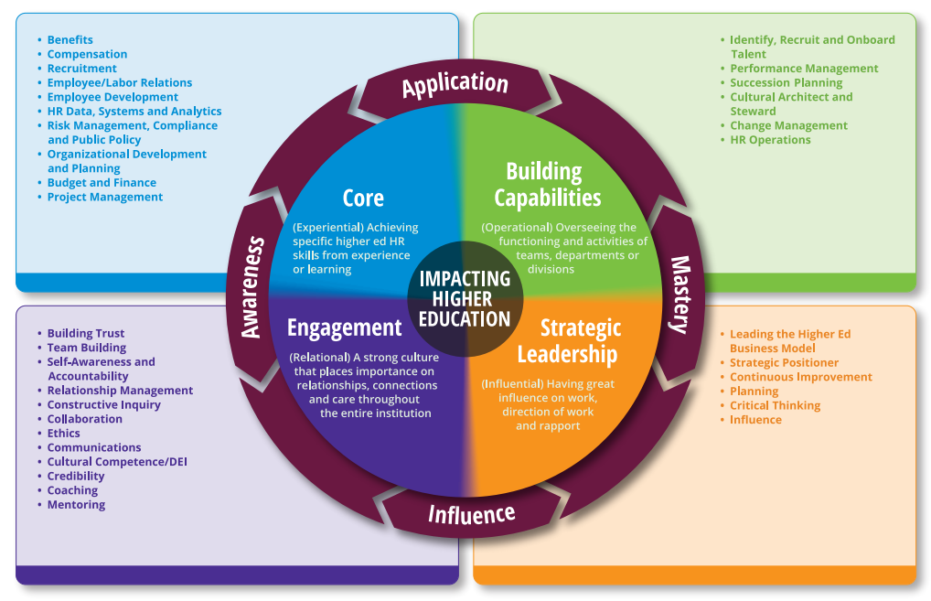
Tip: If you’re not familiar with the Learning Framework, or if you’re having trouble deciding which area and related competencies might apply to your proposal, you can explore the
Learning Framework further on the CUPA-HR website.

Select the area of the CUPA-HR Learning Framework that best represents your presentation’s focus.

Select the primary competency from the selected area of the CUPA-HR Framework that best represents your presentation's content.

If you have questions about how your session topic idea fits into the framework, you can e-mail learn@cupahr.org for help.

Conference Track:
Select the conference track that best represents your presentation's content.
  - Academic HR
  - HR Data, Systems and Analytics
  - DEI/Cultural Competence
  - HR Operations
  - Organizational and Professional Development
  - Risk Management, Compliance and Public Policy
  - Strategy
  - Talent Management

(Optional) Additional Information:
Provide any additional information about your session proposal for which you wish the selection committee to be aware.

4. Provide Your Speaker(s) Information
Use this section to capture the information for the speakers for your session proposal.

Speakers:
You may select up to four speakers. For each speaker, you will need the following information:
First Name:

Last Name:

E-Mail:

Title:

Institution/Organization:

Telephone:

Speaker Introduction:
Provide 1-3 sentences to serve as a brief speaker introduction.

Example:
Shiona Christensen is the director of member engagement at CUPA-HR. She has been with the association for more than 15 years, serving as a member of the marketing and communications and conferences and events teams prior to stepping into her current role. Shiona is a graduate of Appalachian State University and holds her CMP certification.

5. Review, Revise and Submit Your Proposal
Return to the beginning of this document and review and revise your session proposal draft as needed. It is strongly recommended that you proofread your proposal in this Word document, as work in the online form cannot be saved along the way, and spelling/grammar checks are not available. Once you have reviewed your proposal draft, click the “Submit a Presentation Proposal” button on the Call for Presentation Proposals page to access the online proposal form and transfer your proposal information from this guide into the online form for submission.

